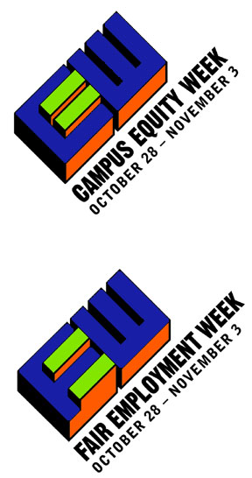
P
A WEEK OF ACTION
Contingent Academic Labor
AAUP – AFT – ASCCC – CAUT – CCA – CCC/CFT – CFA – COCAL – CPFA – CTA – CUPFA
CWA – FACCC – FNEEQ-CSN – MTA – NAFFE – NCHE – NCTE/CCCC – NEA – UC-AFT
www.cewAction.org
Institutions of Higher Education
increasingly exploit part-time and
non-tenure track faculty hired with
No employment security, No benefits,
Little institutional support, Few opportun-
ities for professional development, and
with compensation at a small fraction of that
paid to their tenured colleagues.
*****
CEW is being sponsored by a coalition of
Academic Organizations, Professional Associations,
and Faculty Unions across Canada and the United
States. Activities are encouraged on all campuses
to educate the public and policy makers about this
threat to the quality of higher education.
Our professional responsibility to our students and their future
demand our action as we plan for the Fall.
JOIN YOUR COLLEAGUES NOW!
Email to cewAction-subscribe@topica.com

CEW

Campus Equity Week 2001

October 28 – November 3

Higher Education

