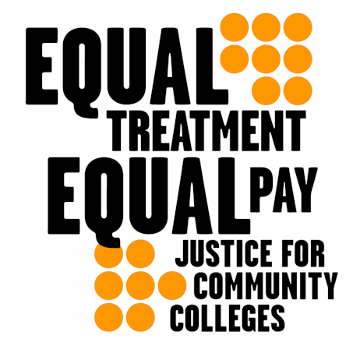

October 28 - November 3

Do Your Part for Equity on Our College Campuses!
Seattle Community Colleges Federation of Teachers
1500 Harvard Avenue Seattle WA 98122
(206) 587-5478
Call Today for More Information and To Get Involved!

