Olympic College Equal Pay for Equal Work Petition
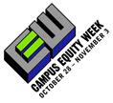 | 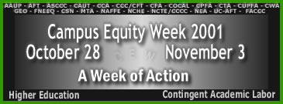
We, the undersigned, believe that compensation for part-time employment should be the corresponding fraction for a full-time position having qualitatively similar responsibilities and qualifications.

We call on Governor Locke and members of the Washington State legislature to consider the compensation for community college faculty among the chief priorities facing higher education in our state.

Name | Address | Signature

